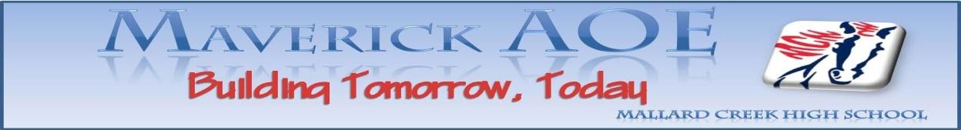

AOE Board Meeting
7:30 to 8:30AM - Career Center
Tuesday, October 11, 2016

- Welcome
  - New members
    - Valerie Hein Hunter – Hunter & Hein, PLLC Attorneys at Law
    - Rick Jenkins – Bank of America – was a parent member but can now use company logo so that we earn credit as an “industry” member
    - Dr. Jacob Garbini – CPCC

- Updates
  - Good news
    - Ms. Alexander, a Spanish teacher at MCHS has connected us with a local contractor (WAC Contracting in Mooresville) who is very passionate about education outreach with his company. We are looking into possible partnership opportunities with his company. Additionally, he has connected us with the Charlotte chapter of NARI (National Association of the Remodeling Industry). They have invited us to their next chapter meeting and even created a new Educational Outreach Committee to handle partnership opportunities with MCHS as well as other CMS schools! Mrs. Parlier and others from CMS will attend their next meeting to explore opportunities for partnership.
  - ACE Mentoring
    - We had 6 students attend the first session of this mentor program (Architecture, Construction & Engineering). Students are still eligible to participate as long as they register at www.acementor.org and attend the next meeting (schedule attached).
  - Etiquette Luncheon
    - We discussed trying to get mock interviews done during this event but decided that it would be too rushed to get them through interviews as well as tour the facility and work with the etiquette coach.
    - Any board member interested in attending the luncheon may do so by paying $22 for the cost of the lunch. Please let Mrs. Parlier know by Wednesday, October 19th if you plan to attend.
  - December meeting – site change
    - MYEP interviews will be held in the Career Center during the December Board meeting so we will plan to meet in the Principal’s Conference room.
  - Internship info for 11th graders
    - All information, dates, applications, agendas, etc. for all internship options (including MYEP, Apprenticeship 2000 and Summer Internship Simulation) will be distributed to students during the Etiquette Luncheon.
  - Restructuring the AOE Board based on NAF recommendations
    - After discussing with NAF personnel, we will be changing our Board listings to include 2 groups: immediate support and outlying support. By identifying these two distinct groups (all of whom are vital to our success), we will be in compliance with our 80% industry standard and therefore, meet our goal for Board membership!!! The first group (immediate support) will include Mrs. Parlier, Ms. Crawford, Terry Jordan from UNCC and all industry members. Group two will include all parents, teachers, students, alumni, additional post-secondary members, and additional school-based personnel.

- Summer Internship Simulation
  - Possible change in format – we discussed holding the simulation immediately after teacher workdays but voted to keep the M-F format. This year’s session will be June 19-23.

- Dave & Buster’s Spirit Night –
  - Mrs. Parlier and AOE officers will be responsible for setting up and running family events and drawings for door prizes throughout the evening.
  - We will need Board members to man a table during the evening to share ways folks can get more involved with AOE. Preferably, we will have someone there from 5:30-9:30. Please let Mrs. Parlier know if you are available to man the table for a one hour block.

Upcoming dates:

October 14 – PreACT
October 18 – Parlier, Helms, Romain to NAF Master Scheduling conference
October 19 – PreSAT
October 19 – second meeting of ACE Mentoring program – final opportunity to participate if interested
October 24 – Etiquette Luncheon @ Great Wolf Lodge
October 26-27 – Midterms
October 27 – Parlier to NARI meeting
October 28-31 – Fall Break
October 31 – Parlier & Garay to NAF Fall planning conference
November 8 – No school
November 10 – Spirit Night @ Dave & Buster’s
November 11 – No school
November 21 – WorkKeys testing - seniors
November 23-27 – Thanksgiving Break
November 29 – Job Skills Training (in house field trip)
December 13 – Board meeting
December 13 – MYEP Interviews
December 22 – January 3 – Winter Break
January 16 – No school
January 17-23 – Final exams
January 24 – no school
February 14 – Board meeting
February 17 - no school
February 20 – no school
March 7 – Early release day
March 14 – Board meeting
March 31 – no school
April 7-16 – Spring break
April 18 – Board meeting
April 26 – Early release day
May 9 – Board meeting
May 29 – No school
June 5-8 Final exams
June 19-23 – Summer Internship Simulation

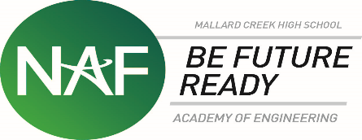

In attendance: Robin Swartz, Jennifer Raley, Rick Jenkins, Robert Jenkins, Andree Sharrieff, Gail McDougal, Lynn Comstock, Karlene Crawford, Valerie Hunber, Kristin Helms

Online: Connie Bradley, Eric Henshaw, Vincent Orguno, Jared Young

