Agenda – AOE Advisory Board Meeting February 14, 2017 7:30 am
Introduction - Mr. Swift – incoming Academy Coordinator Mr. Swift
NAF Update Mr. Swift
Project Lead the Way Update Mr. Swift
AOE Class Field Trips Mr. Swift
9th Grade Spectrum Center 3/8
10th Grade Le Grande 2/27
11th Grade Merchandise Mart April TBD
12th Grade Go Pro April TBD
Internship Update
Scholarship Update
Revisit Non-Profit Status
Marketing/Sponsorship – designee
Secretary - designee

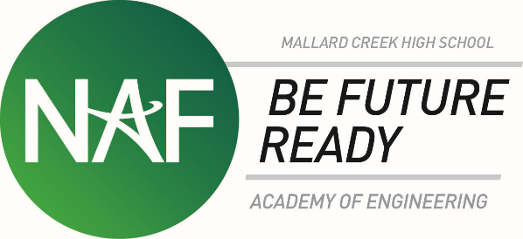

AOE Board meeting 2/14/17
-Introduction of Mr. Swift as new AOE coordinator
-Mr. Swift has set up a remind for the advisory board to maintain contact for the board

NAF Update-Had NAF meeting on last Thursday; Mr. Garay and Mr. Swift attended; NAF would like for the board to run the meetings
-MCHS is attempting to go from Model Academy to Distinguished academy
-at the NAF Meeting, scholarships and internships was a topic of discussion
-a lot of schools are having difficulty with getting internships
-at MCHS was do the internships over the summer using MYEP and the summer simulation
-one thing to work on is to get more scholarships for our AOE students
-university in FL that is writing a grant; if grant goes through they could possibly use us as a “model” for their project; monetary benefits would be paid in 3 installments; one during each of the 3 visits to the school

PLTW Update
-at the NAF meeting, PLTW president was guest speaker; he visited MCHS
-talked about importance of recruitment from Middle and Elementary schools
-need for schools to get students interested sooner; bigger push for this
-hands on visit from the president of PLTW, visited classrooms, asked students questions

Field Trip
-9th grade-Spectrum Center 3/8/17
-10th grade- Le Grande 2/27 (engineering firm in Concord)
-11th grade- Merchandise Mart April (TBD)
-12th grade- Go Pro

-other field trip opportunity possibly with an engineering firm that is testing tires; facility is located off Sunset or Beatties Ford; indoor track and giant mechanism that they put tires on and run tires around track to test the tires
-possibly pairing the VEX kids with the engineers for creating robot
-VEX camp paring with the elementary kids--our students could possibly mentor the younger students to help with interest at younger age
-also will have the middle school visits coming up

Internship update
-summer simulation and MYEP for our Juniors
-summer internship at MCHS is set and ready to go
-Mr. Lewis has committed to work with students for the week of our internship process here at MCHS (June 19-23)

Scholarship Update
-AOE board will be awarding two $500 scholarships
Non-profit status
-possibly we have one person that was on the board that was an attorney that could help with 501c3; AOE board stuck in this process; have not been able to get 501c3 up and going
-item to continue being worked on

Other items
-need to designate specific people for specific jobs
-Ms. Reilly has agreed to be the point of contact for the Non-Profit Status--will contact Kristi to find out who we were working with
-Ms. Bradley--possibly who can work on the Marketing/Sponsorships designee
-Ms. Helms-Secretary/note taking designee

-for next meeting--Mr. Swift will update on all of the field trips that are upcoming for the school year
-Mr. Swift will follow-up with Ms. Bradley regarding the marketing
-Ms. Reilly will follow up with Kristi regarding 501c3 contact
-Mr. Jenkins will follow up Ms. Comstock regarding new possibilities
-Ms. Schwartz will be point of contact for VEX class curriculum at JM Robinson

-discussion on VEX Camp-possibly partner with JM Robinson; for this year, possibly send students to the camp to see how it works and how many students we could get from our area to go over there; would it be beneficial for us to host a summer camp?

-question for next meeting--March 14

